**LAB 6**

**K20-1052**

**HASSAN ALI**

**Q1.**

var Name = "HP PAVILION";

let series = "15";

year = 2020;

const product = {

  Name: Name,

  series: series,

  year: year,

};

console.log(product);

**Q2.**

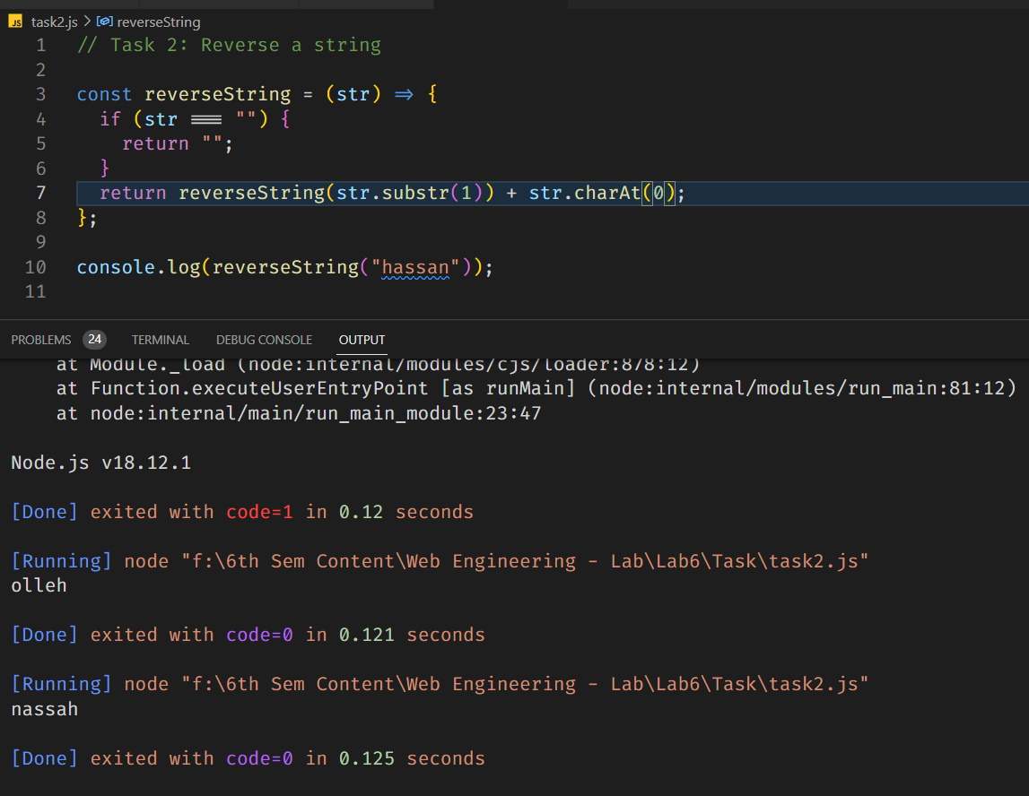

// Task 2: Reverse a string

const reverseString = (str) => {

  if (str === "") {

    return "";

  }

  return reverseString(str.substr(1)) + str.charAt(0);

};

console.log(reverseString("hassan"));

**Q3.**

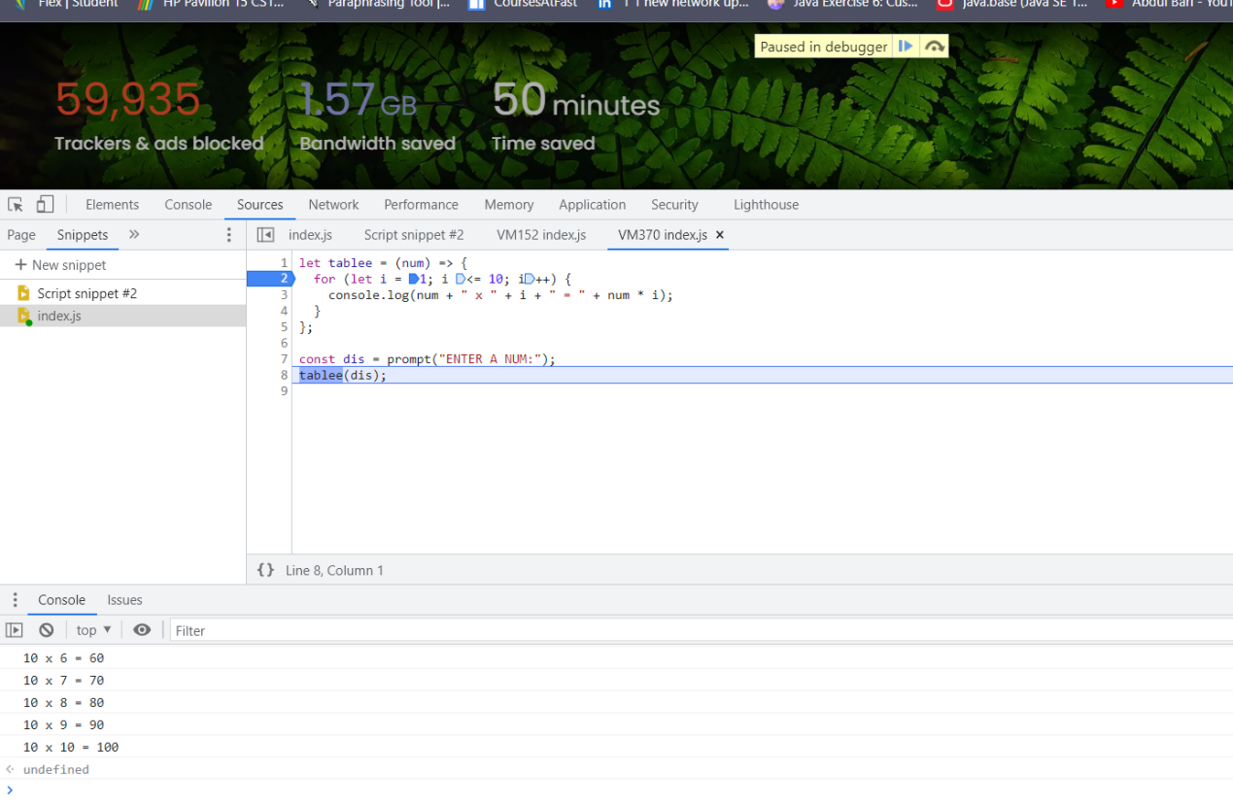

const tablee = (num) => {

  for (let i = 1; i <= 10; i++) {

    console.log(num + " x " + i + " = " + num * i);

  }

};

const dis = prompt("ENTER A NUM:");

tablee(dis);

**Q4.**

<!DOCTYPE html>

<html lang="en">

  <head>

    <title>JavaScript Calculator</title>

    <style>

      body {

        font-family: Arial, sans-serif;

        background-color: #f2f2f2;

      }

      h1 {

        text-align: center;

      padding: 20px;

        background-color: #4caf50;

        color: white;

      }

      #clear {

        width: 270px;

        border: 3px solid gray;

        border-radius: 3px;

        padding: 20px;

        background-color: red;

        color: white;

        font-size: 18px;

        margin-top: 20px;

        cursor: pointer;

      }

      .formstyle {

        width: 300px;

        height: 510px;

        margin: 20px auto;

        border: 3px solid skyblue;

        border-radius: 5px;

        padding: 20px;

        background-color: white;

        box-shadow: 0 0 10px rgba(0, 0, 0, 0.3);

      }

      input[type="text"] {

        width: 250px;

        background-color: #f2f2f2;

        color: black;

        border: none;

        border-bottom: 2px solid gray;

        font-size: 28px;

        text-align: right;

        margin-bottom: 10px;

      }

      input[type="button"] {

        width: 60px;

        background-color: #4caf50;

        color: white;

        border: none;

        border-radius: 5px;

        padding: 20px;

        margin: 5px;

        font-size: 20px;

        cursor: pointer;

        box-shadow: 0 0 5px rgba(0, 0, 0, 0.3);

      }

      input[type="button"]:hover {

        background-color: #3e8e41;

      }

      input[type="button"]:active {

        background-color: #4caf50;

        box-shadow: none;

      }

    </style>

  </head>

  <body>

    <h1>JS Calculator</h1>

    <div class="formstyle">

      <form name="form1">

        <!-- This input box shows the button pressed by the user in calculator. -->

        <input id="calc" type="text" name="answer" /> <br />

        <br />

        <!-- Display the calculator button on the screen. -->

        <!-- onclick() function display the number prsses by the user. -->

        <input type="button" value="1" onclick="form1.answer.value += '1' " />

        <input type="button" value="2" onclick="form1.answer.value += '2' " />

        <input type="button" value="3" onclick="form1.answer.value += '3' " />

        <input type="button" value="+" onclick="form1.answer.value += '+' " />

        <br />

        <br />

        <input type="button" value="4" onclick="form1.answer.value += '4' " />

        <input type="button" value="5" onclick="form1.answer.value += '5' " />

        <input type="button" value="6" onclick="form1.answer.value += '6' " />

        <input type="button" value="-" onclick="form1.answer.value += '-' " />

        <br />

        <br />

        <input type="button" value="7" onclick="form1.answer.value += '7' " />

        <input type="button" value="8" onclick="form1.answer.value += '8' " />

        <input type="button" value="9" onclick="form1.answer.value += '9' " />

        <input type="button" value="*" onclick="form1.answer.value += '*' " />

        <br />

        <br />

        <input type="button" value="/" onclick="form1.answer.value += '/' " />

        <input type="button" value="0" onclick="form1.answer.value += '0' " />

        <input type="button" value="." onclick="form1.answer.value += '.' " />

        <!-- When we click on the '=' button, the onclick() shows the sum results on the calculator screen. -->

        <input

          type="button"

          value="="

          onclick="form1.answer.value = eval(form1.answer.value) "

        />

        <br />

        <!-- Display the Cancel button and erase all data entered by the user. -->

        <input

          type="button"

          value="Clear All"

          onclick="form1.answer.value = ' ' "

          id="clear"

        />

        <br />

      </form>

    </div>

  </body>

</html>

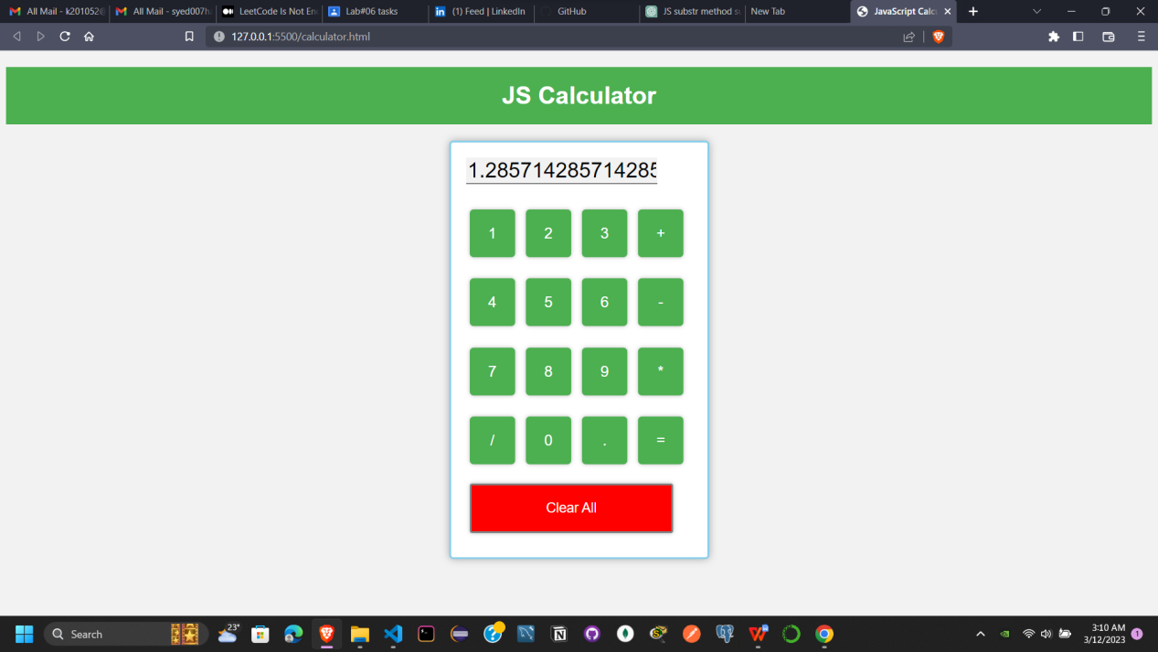

**Q5.**

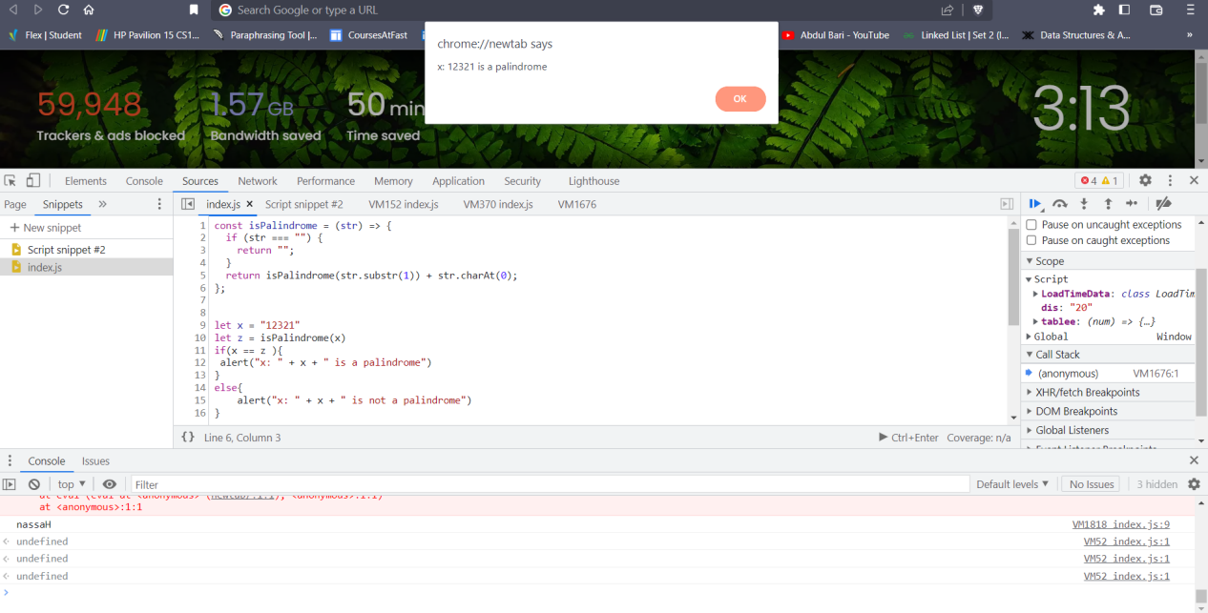

const isPalindrome = (str) => {

  if (str === "") {

    return "";

  }

  return isPalindrome(str.substr(1)) + str.charAt(0);

};

let x = "12321";

let z = isPalindrome(x);

if (x == z) {

  alert("x: " + x + " is a palindrome");

} else {

  alert("x: " + x + " is not a palindrome");

}

**Q6.**

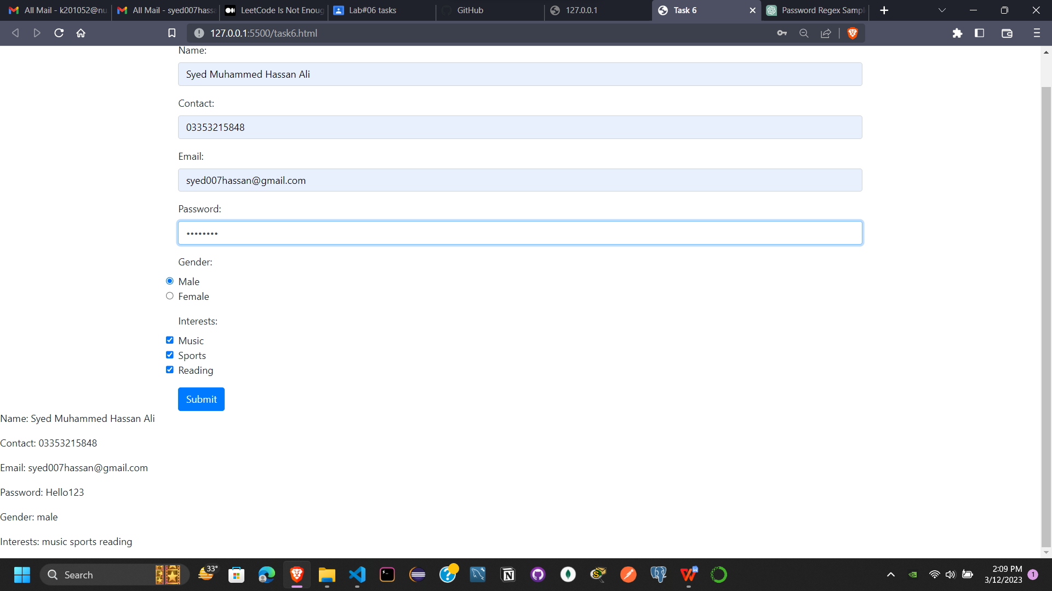

<!DOCTYPE html>

<html lang="en">

  <head>

    <meta charset="UTF-8" />

    <meta http-equiv="X-UA-Compatible" content="IE=edge" />

    <meta name="viewport" content="width=device-width, initial-scale=1.0" />

    <title>Task 6</title>

    <script src="task6.js"></script>

    <!-- Add Bootstrap CSS -->

    <link

      rel="stylesheet"

      href="https://maxcdn.bootstrapcdn.com/bootstrap/4.5.2/css/bootstrap.min.css"

    />

  </head>

  <body>

    <div class="container mt-5">

      <form name="signup" onsubmit="return validateForm()">

        <div class="form-group">

          <label for="name">Name:</label>

          <input type="text" id="name" name="name" class="form-control" />

        </div>

        <div class="form-group">

          <label for="contact">Contact:</label>

          <input type="tel" id="contact" name="contact" class="form-control" />

        </div>

        <div class="form-group">

          <label for="email">Email:</label>

          <input type="email" id="email" name="email" class="form-control" />

        </div>

        <div class="form-group">

          <label for="password">Password:</label>

          <input

            type="password"

            id="password"

            name="password"

            class="form-control"

          />

        </div>

        <div class="form-group">

          <label for="gender">Gender:</label>

          <div>

            <input

              type="radio"

              id="male"

              name="gender"

              value="male"

              class="form-check-input"

            />

            <label for="male" class="form-check-label">Male</label>

          </div>

          <div>

            <input

              type="radio"

              id="female"

              name="gender"

              value="female"

              class="form-check-input"

            />

            <label for="female" class="form-check-label">Female</label>

          </div>

        </div>

        <div class="form-group">

          <label for="interests">Interests:</label>

          <div>

            <input

              type="checkbox"

              id="music"

              name="interests"

              value="music"

              class="form-check-input"

            />

            <label for="music" class="form-check-label">Music</label>

          </div>

          <div>

            <input

              type="checkbox"

              id="sports"

              name="interests"

              value="sports"

              class="form-check-input"

            />

            <label for="sports" class="form-check-label">Sports</label>

          </div>

          <div>

            <input

              type="checkbox"

              id="reading"

              name="interests"

              value="reading"

              class="form-check-input"

            />

            <label for="reading" class="form-check-label">Reading</label>

          </div>

        </div>

        <button type="submit" class="btn btn-primary">Submit</button>

      </form>

      <div id="display"></div>

    </div>

    <!-- Add Bootstrap JS (jQuery and Popper.js) -->

    <script src="https://code.jquery.com/jquery-3.5.1.slim.min.js"></script>

    <script

      src="https://cdn.jsdelivr.net/npm/@popperjs/core@2.10.1/dist/umd/popper.min.js"

      integrity="sha384-W5DiFjC1hepcVGgKTfOLqJp3wL5lxKb5ru5YX2+6Zp6Y7rVQ4sWkhk+8WvCWPIPm49"

      crossorigin="anonymous"

    ></script>

    <script src="https://stackpath.bootstrapcdn.com/bootstrap/4.5.2/js/bootstrap.min.js"></script>

  </body>

</html>

function displayValues() {

  var name = document.forms["signup"]["name"].value;

  var contact = document.forms["signup"]["contact"].value;

  var email = document.forms["signup"]["email"].value;

  var password = document.forms["signup"]["password"].value;

  var gender = document.querySelector('input[name="gender"]:checked');

  var interests = document.querySelectorAll('input[name="interests"]:checked');

  var namePara = document.createElement("p");

  var contactPara = document.createElement("p");

  var emailPara = document.createElement("p");

  var passwordPara = document.createElement("p");

  var genderPara = document.createElement("p");

  var interestsPara = document.createElement("p");

  namePara.innerHTML = "Name: " + name;

  contactPara.innerHTML = "Contact: " + contact;

  emailPara.innerHTML = "Email: " + email;

  passwordPara.innerHTML = "Password: " + password;

  genderPara.innerHTML = "Gender: " + gender.value;

  interestsPara.innerHTML = "Interests: ";

  for (var i = 0; i < interests.length; i++) {

    interestsPara.innerHTML += interests[i].value + " ";

  }

  document.body.appendChild(namePara);

  document.body.appendChild(contactPara);

  document.body.appendChild(emailPara);

  document.body.appendChild(passwordPara);

  document.body.appendChild(genderPara);

  document.body.appendChild(interestsPara);

}

function validateForm() {

  var name_regex = /^[A-Za-z ]+$/;

  var contact_regex = /^\d{11}$/;

  var email_regex = /^[^\s@]+@[^\s@]+\.[^\s@]+$/;

  var password_regex = /^(?=.*\d)(?=.*[a-z])(?=.*[A-Z])[0-9a-zA-Z]{8,}$/;

  var name = document.forms["signup"]["name"].value;

  var contact = document.forms["signup"]["contact"].value;

  var email = document.forms["signup"]["email"].value;

  var password = document.forms["signup"]["password"].value;

  var gender = document.querySelector('input[name="gender"]:checked');

  var interests = document.querySelectorAll('input[name="interests"]:checked');

  if (!name_regex.test(name)) {

    alert("Please enter a valid name.");

    return false;

  }

  if (!contact_regex.test(contact)) {

    alert("Please enter a valid 10-digit phone number.");

    return false;

  }

  if (!email_regex.test(email)) {

    alert("Please enter a valid email address.");

    return false;

  }

  if (!password_regex.test(password)) {

    alert(

      "Please enter a password that is at least 8 characters long and contains at least one uppercase letter, one lowercase letter, and one number."

    );

    return false;

  }

  if (!gender) {

    alert("Please select a gender.");

    return false;

  }

  if (interests.length < 1) {

    alert("Please select at least one interest.");

    return false;

  }

  displayValues();

  return false;

}

**Q7.**

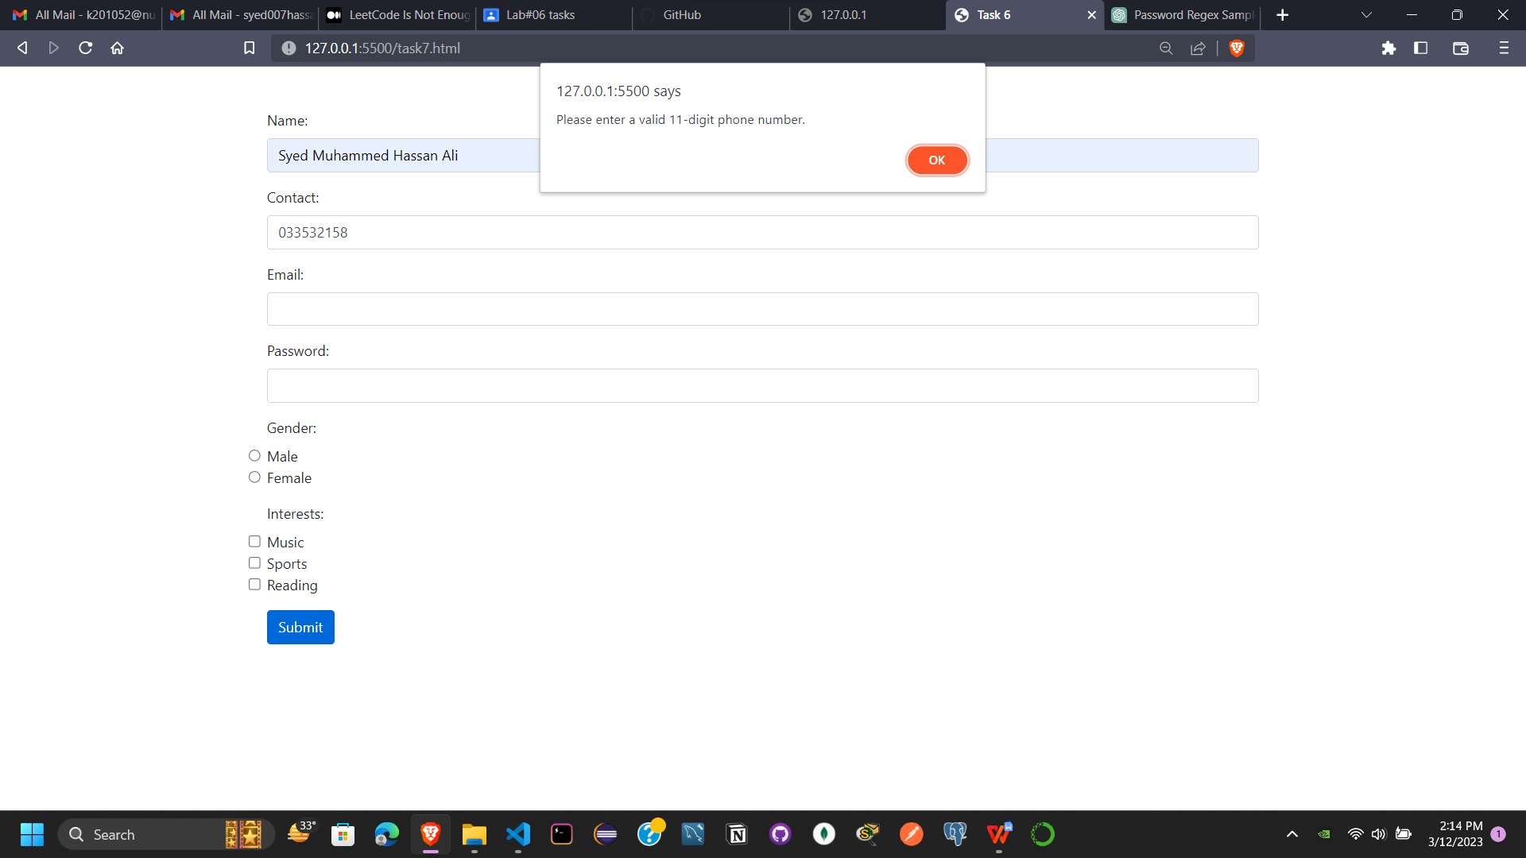

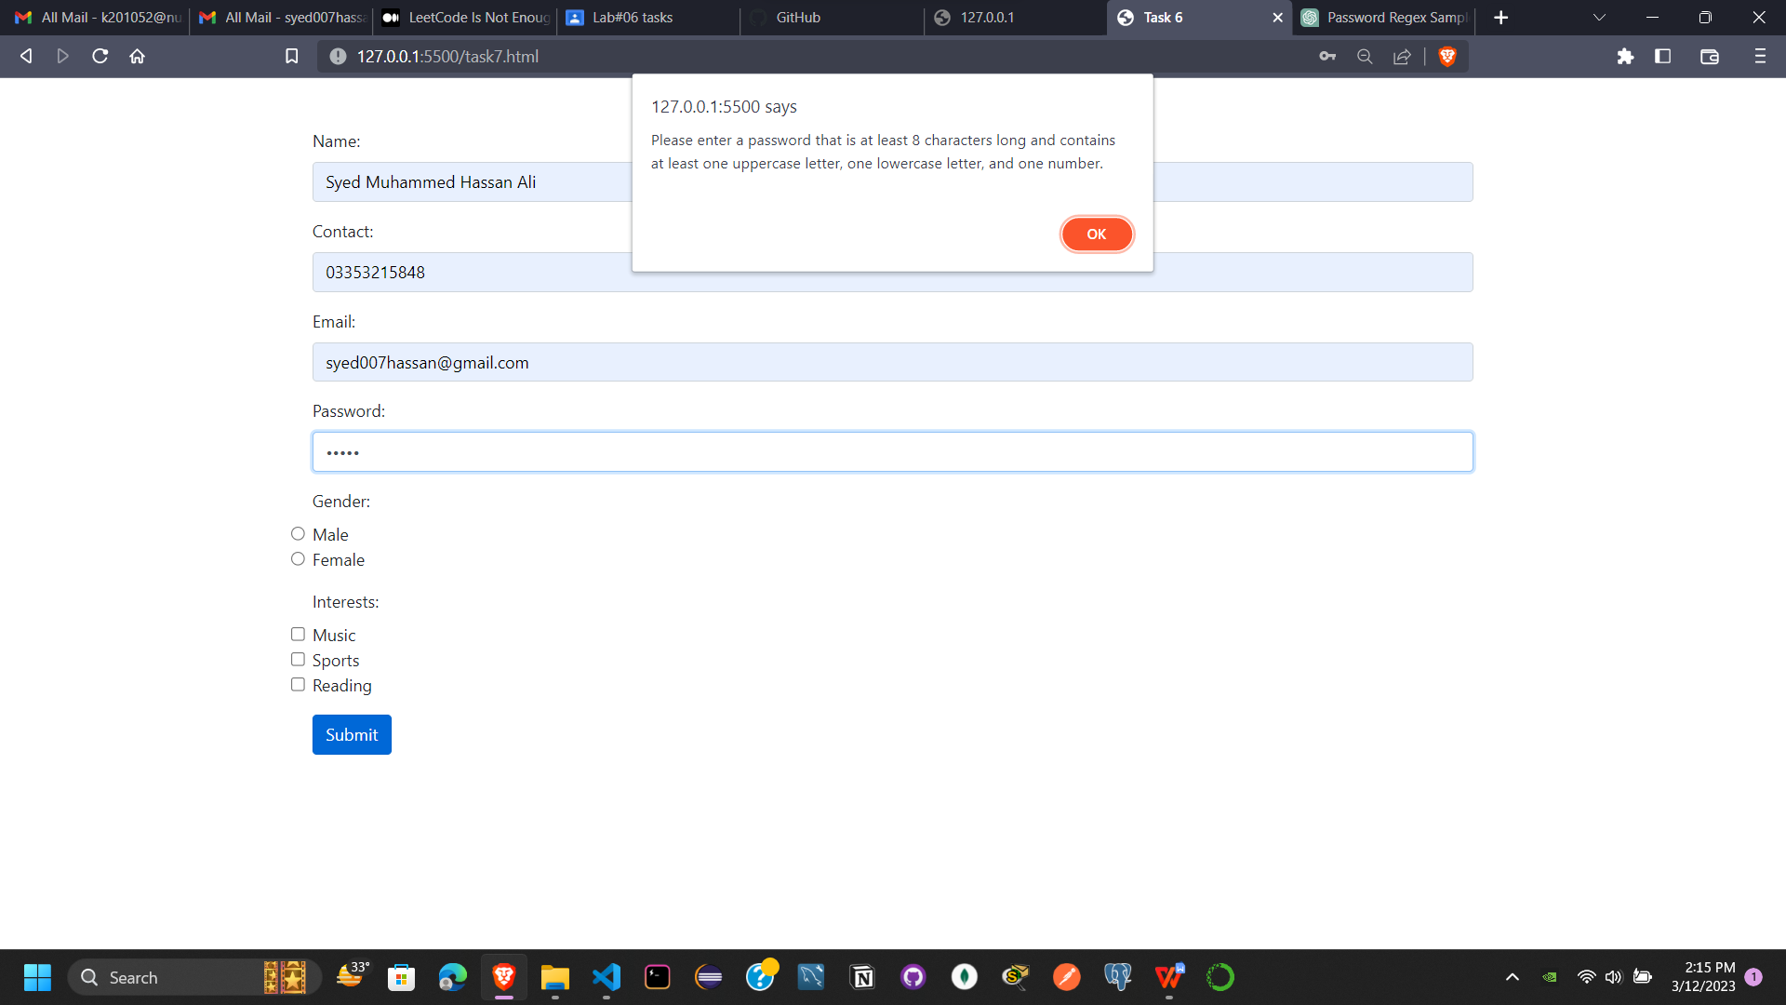

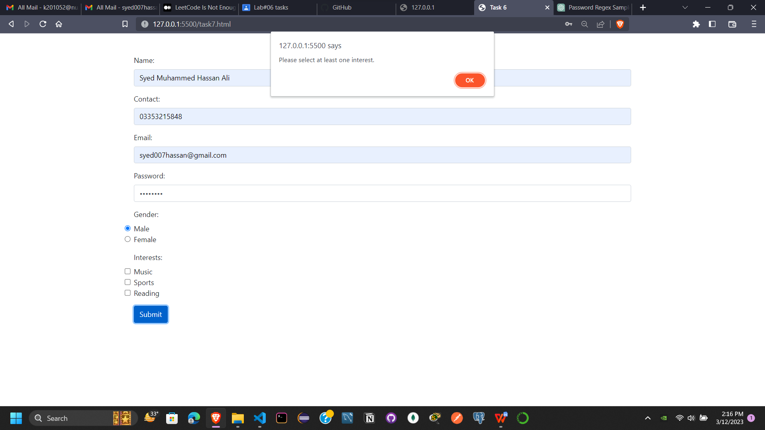

function validateForm() {

  // Regular expressions for validation

  var name_regex = /^[A-Za-z ]+$/;

  var contact_regex = /^\d{11}$/;

  var email_regex = /^[^\s@]+@[^\s@]+\.[^\s@]+$/;

  var password_regex = /^(?=.*\d)(?=.*[a-z])(?=.*[A-Z])[0-9a-zA-Z]{8,}$/;

  // Get form input values

  var name = document.forms["signup"]["name"].value;

  var contact = document.forms["signup"]["contact"].value;

  var email = document.forms["signup"]["email"].value;

  var password = document.forms["signup"]["password"].value;

  var gender = document.querySelector('input[name="gender"]:checked');

  var interests = document.querySelectorAll('input[name="interests"]:checked');

  // Validate name field

  if (!name_regex.test(name)) {

    alert("Please enter a valid name.");

    return false;

  }

  // Validate contact field

  if (!contact_regex.test(contact)) {

    alert("Please enter a valid 11-digit phone number.");

    return false;

  }

  // Validate email field

  if (!email_regex.test(email)) {

    alert("Please enter a valid email address.");

    return false;

  }

  // Validate password field

  if (!password_regex.test(password)) {

    alert(

      "Please enter a password that is at least 8 characters long and contains at least one uppercase letter, one lowercase letter, and one number."

    );

    return false;

  }

  // Validate gender field

  if (!gender) {

    alert("Please select a gender.");

    return false;

  }

  // Validate interests field

  if (interests.length < 1) {

    alert("Please select at least one interest.");

    return false;

  }

  // Form validated successfully

  alert("Form validated successfully!");

  return true;

}

**Q8.**

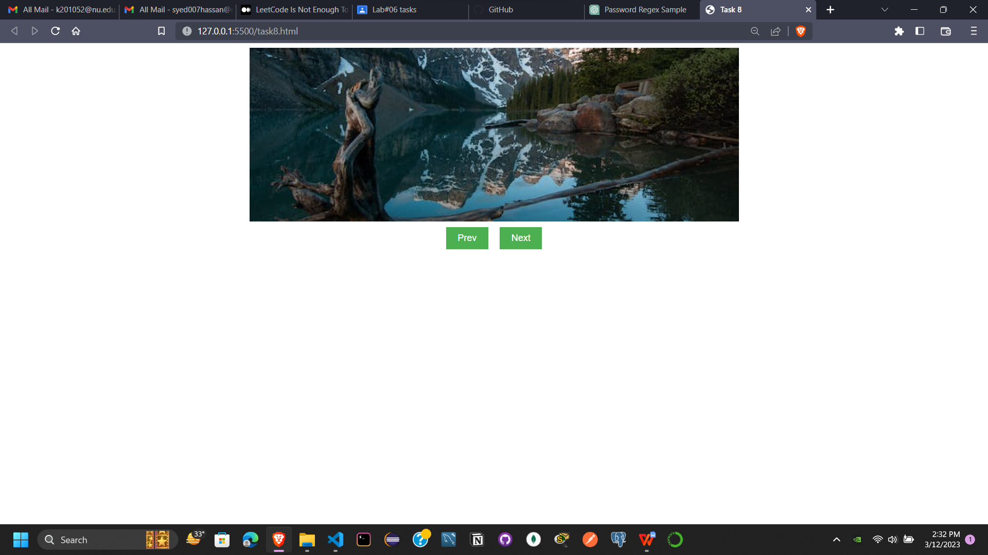

<!DOCTYPE html>

<html lang="en">

  <head>

    <meta charset="UTF-8" />

    <meta http-equiv="X-UA-Compatible" content="IE=edge" />

    <meta name="viewport" content="width=device-width, initial-scale=1.0" />

    <title>Task 8</title>

<style>

      .slider {

        position: relative;

      }

      .slider img {

        position: absolute;

        top: 0;

        left: 0;

        opacity: 0;

        transition: opacity 0.5s;

      }

      .slider img.active {

        opacity: 1;

      }

      .slider {

        position: relative;

        width: 50%;

        margin: 0 auto;

        height: 300px;

        overflow: hidden;

      }

      .slider img {

        position: absolute;

        top: 0;

        left: 0;

        opacity: 0;

        transition: opacity 0.5s;

        width: 100%;

        height: 100%;

        object-fit: cover;

      }

      .slider img.active {

        opacity: 1;

      }

      button {

        background-color: #4caf50;

        border: none;

        color: white;

        padding: 10px 20px;

        text-align: center;

        text-decoration: none;

        display: inline-block;

        font-size: 16px;

        margin: 10px;

        cursor: pointer;

      }

      button:hover {

        background-color: #3e8e41;

      }

      button:active {

        background-color: #3e8e41;

        transform: translateY(2px);

      }

      .bt {

        display: flex;

        justify-content: center;

        align-items: center;

      }

    </style>

  </head>

  <body>

    <div class="slider">

      <img

        src="https://images.pexels.com/photos/2325446/pexels-photo-2325446.jpeg?auto=compress&cs=tinysrgb&w=600"

        alt="Image 1"

        class="active"

      />

      <img

        src="https://images.pexels.com/photos/2662116/pexels-photo-2662116.jpeg?auto=compress&cs=tinysrgb&w=600"

        alt="Image 2"

      />

      <img

        src="https://images.pexels.com/photos/2387418/pexels-photo-2387418.jpeg?auto=compress&cs=tinysrgb&w=600"

        alt="Image 3"

      />

    </div>

    <div class="bt">

      <button onclick="prev()">Prev</button>

      <button onclick="next()">Next</button>

    </div>

  </body>

  <script>

    let images = document.querySelectorAll(".slider img");

    let index = 0;

    function next() {

      images[index].classList.remove("active");

      index = (index + 1) % images.length;

      images[index].classList.add("active");

    }

    function prev() {

      images[index].classList.remove("active");

      index = (index - 1 + images.length) % images.length;

      images[index].classList.add("active");

    }

  </script>

</html>